Membership Under the Florida Sun 🌞 September 1, 2025
A Note from Your Membership Director
Last fall was my first year as Florida Director for Membership, and I was proud to explore our statewide roster. Florida is home to both the longest-standing and newest AAUW members, a true legacy of leadership.
- Looking ahead, I’m focusing on two big initiatives:
Honoring the Past – We’re building a State Memorial Page to remember and celebrate members who have passed. You can help by submitting names here: Memorial Form.
Strengthening University Partnerships – I’ve compiled a list of Florida public colleges and universities to contact. Let’s work together to bring institutions on board! Learn more: Florida Colleges & Universities (new page). Please share info about your local institution by filling out this University Outreach Survey.
- Upcoming Membership Meeting Join me for an Online Membership Analysis Meeting on Google Meet Video (similar to Zoom but easier): Thursday September 9 at 6:00 p.m. ET (Link opens at 5:30 for testing) 🔗 Google Calendar Invite

- State Membership Engagement
Boost member participation and retention by promoting AAUW Florida Online Book Club. If your branch has no events scheduled for September this is perfect. Fall Virtual/Online Book Club – Keep members engaged all year! Open to all. Contact Doris at dorisnoble20016@yahoo.com.

Merchandise – Check out branded AAUW Florida items and new milestone pins. Contact Christina Evette: (843) 412-3817 or visit christinaevette.com.
- Our new membership handbook is designed to help you succeed. It includes an overview of your responsibilities and time-saving tips, sample welcome emails, sign-in sheets, and application forms. Learn to navigate the Community Hub and retrieve rosters with our step-by-step guide. Utilize free office tools, create QR codes, and follow our tutorials with pictures and https://docs.google.com/document/d/1iGfHaCcJ0hskUtD7m85GjLESi0Pyz-6jPsQXtNsC_L4/edit?usp=sharing

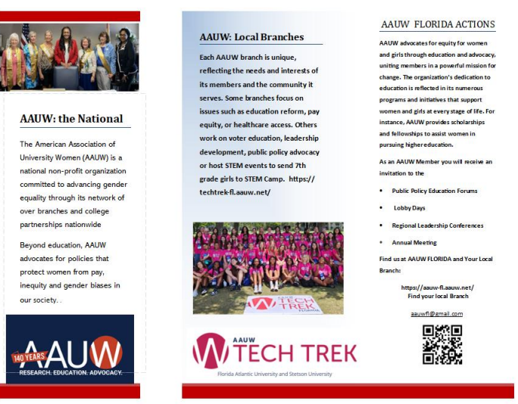

- Special appreciation to our Membership VPs and Treasurers for your tireless work on recruitment and processing applications. I’ll be sharing step-by-step portal tips (with screenshots) to make entering and managing memberships easier. If you need help exporting your roster, email me at aauwflempowerment@usf.edu.
Welcome to New Membership VPs and Treasurers! 🎉
If you haven't accessed the portal yet, please reach out to your supervisor or chain of command for access. Once you’re in, follow these simple steps:
- Log In: AAUW Membership Portal (https://my.aauw.org/myaffiliations )
- Explore: Take a look through the highlighted sections (yellow highlights).
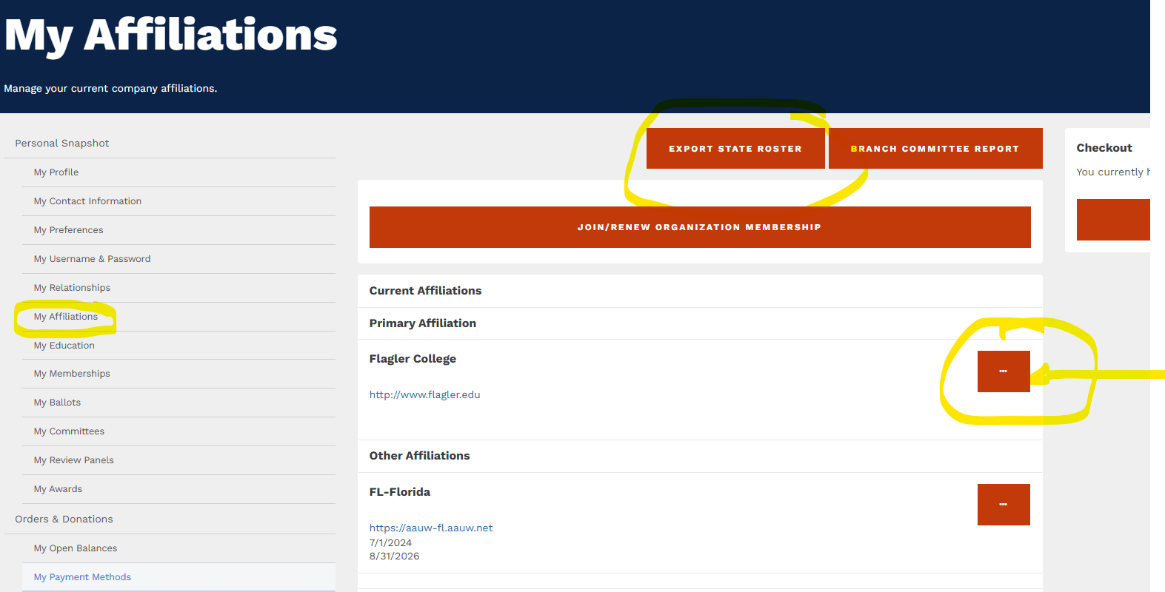
Important Tips for Entering Applications:
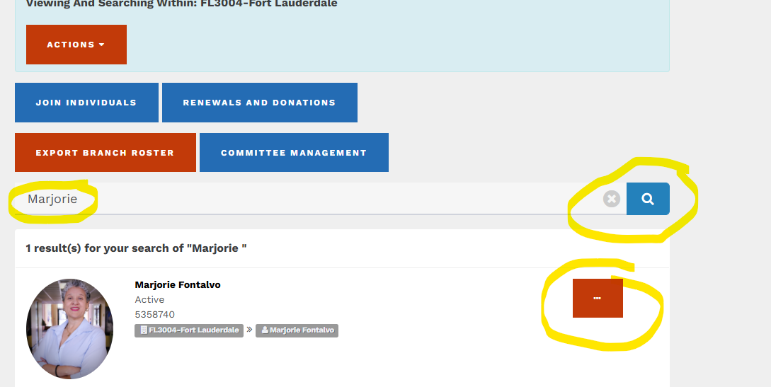
- Avoid entering in the second tab (APT) – it complicates the spreadsheet download process.
- Adding a New Member:
  - In your branch roster, click the three dots next to the member list.
  - Select "Add New Member".
  - Search for their name first to make sure they’re not already in the system. This will ensure a new AAUW ID is created.
You should see these actions below:

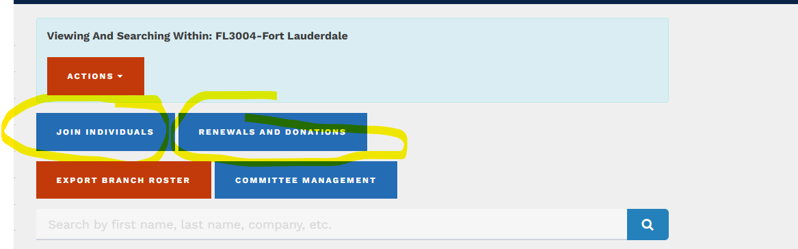

Quick Reminder:
- When typing in the address, don’t start a second line to avoid a second line in Excel records.
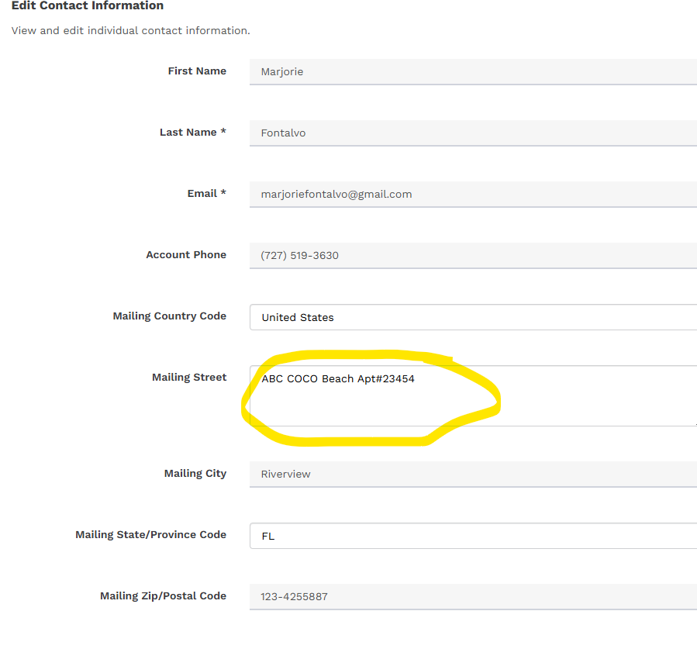

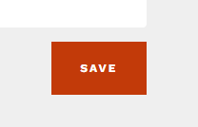
Quick Reminder:
- When typing in the address, don’t start a second line to avoid a second line in Excel records creating a second account name.
Sample:
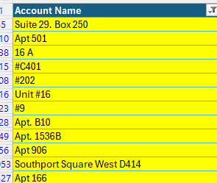
I will continue to clean this data, and I understand that it is just part of the Hub input.
Extra useful YouTube Video How to export your Membership Roster: https://youtu.be/GDQbLtFlGRA
Thank you, leaders!

- Different Topic: Website Help: If you need assistance updating your website, please don’t hesitate to reach out. Regarding the "Members ONLY" or "Private Links" section on our website, I’m still looking into it. It seems to have been last updated in 2020, before my time as Director. I’ve brought it to the attention of the AAUW Florida Board, and we're working to gather more details. I would love to hear more reply for contact us.
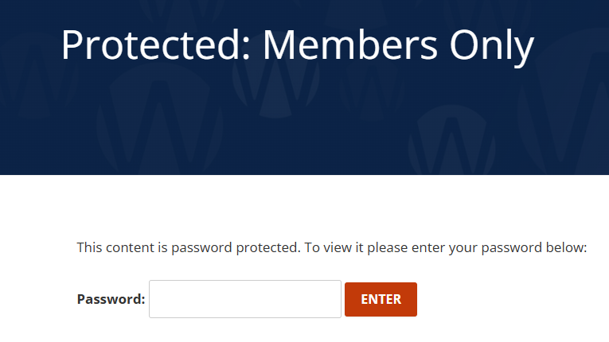

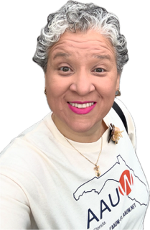
Together, let’s continue growing, honoring, and empowering the AAUW Florida community.
Marjorie Fontalvo
AAUW Florida Director for Membership (2025–2026) https://aauw-fl.aauw.net/membership/

