AAUW Florida Lobby Days 2019
March 12-13, 2019
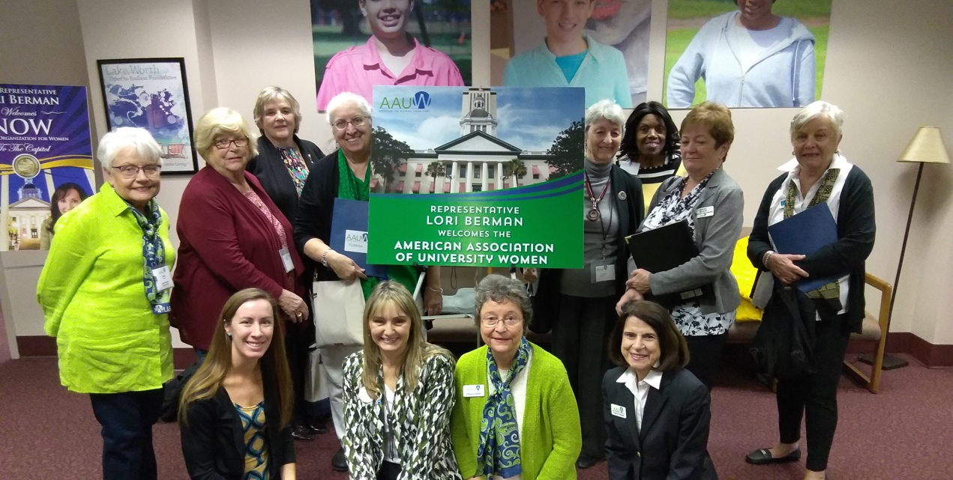
Be There at the Capitol!

- Training session on Monday evening, March 11 at the hotel
  - Visit and advocate with your own legislators and team up with others
  - Information on committee meetings and sessions to attend
  - You will be provided with a concise list of bills to support or oppose that have been vetted by the national office, with talking points. We will also have AAUW materials for you to leave with the legislators’ offices.
- Dinner together Tuesday evening TBA
- Rally, Information Table on Wednesday
- Stipend: graduated scale ($50-$80) depending on your driving distance plus $50 to help with lodging. This is to help with expenses, not cover them.
What to Do Now
- Contact Pat DeWitt, aauwfldewitt@gmail.com, to be put on the email list for updates. No obligation! (I will help match up roommates if desired)
- Make an appointment with your senator or representative NOW. Call and ask for the person who does the scheduling for them (warning: events may conspire to cause the legislator to cancel)
- Build a team from your branch!
- Register at the hotel, Country Inn and Suites, Midway, FL (10 miles from the Capitol): check in 3/11 and check out 3/13. Register at the hotel by Monday, Feb. 18. Call (800) 456-4000 or use the website www.countryinn.com and the promotional code 1903AAUW under More Search Options. Reserved rooms have two queen beds. Rate is $99 single, $108 double plus 9.5% tax, or $108.41 single and $118.26 double.

